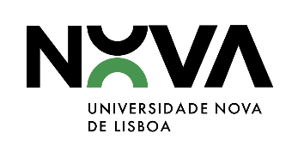
NOVA Pedagogical Innovation Award
2024

INFORMED CONSENT FORM

(full name)___________________________________________________________, hereby confirms that is applying to the Pedagogical Innovation Award at NOVA University Lisbon, under the project________________________________________________________, in which participates, following the respective regulation, as in Regulamento do Prémio de Inovação Pedagógica, published in Diário da República, regulation 129/2021, on February 9th, 2021.
I acknowledge that the purpose of the personal data processing covered by this informed consent form is to correctly identify the applicants of the NOVA Pedagogical Innovation Award 2024.

Photographs and video images containing exclusively my image will only be kept and used by UNL for as long as the adequacy of the data and/or the timeliness and relevance of the contact between me and UNL are verified. UNL may, however, keep and use any group photographs or video images, or images in which my photograph or video image appears only incidentally, as part of global images.

I expressly authorise NOVA to collect photographs and videos with my image to be used in any type of media or publication for the institutional and dissemination purposes of NOVA Pedagogical Innovation Award 2024.

Date______________________________

__________________________________________
Signature

